# Caremark.com – Family Access

Family Access Screen Text

Family Access Screen

Remove Family Access

Questions/Answers

Related Documents

**Description:** Provides information on how members can grant **Family Access** to other **adult** family members covered under the same plan.

**Note:** Family Access does not apply to members covered under Medicare D plans.

|  |
| --- |
| Important Information |

* Customer Care representatives are **not** allowed to alter, change, register, or delete Protected Health Information (PHI). Customer Care representatives **cannot** check or uncheck the **Family Access** boxes for a member. The member must make these selections.
* Always authenticate before releasing PHI to callers or providing someone access to the website. The caller will have access to medical information, billing information, and prescription information on the website.
* Everyone 18 years of age or older has the right to privacy. Some plans may have plan specific ages for registration that may be lower than 18 years of age.
* Information on the Caremark.com website is considered Protected Health Information; as a result, information disclosed or released about account information is protected.

|  |
| --- |
| Family Access Screen Text |

**Note:**  Screen capture may not match actual scenario for this process. Some clients may not enlist in specific web features. This work instruction/job aid is intended as a guide only.

The following verbiageis listed on the **Family Access** screen of the website.

 Please be aware that if you allow a family member access to view your medications, all of your medications will be available to be viewed, including those medications that you may regard as sensitive or of a personal nature. If you do not want medications that you regard as sensitive or of a personal nature to be seen by another family member, you must remove Family Access (if previously granted) for that family member. Refer to [Aetna - Sensitive Drug List (089055)](https://thesource.cvshealth.com/nuxeo/thesource/#!/view?docid=862fbcf7-cb7e-4e7c-adee-0458fb2ab8cb)

**Disclaimer Note** shown from the Family Access page and the Family Access Authorization screen after clicking the “Terms & Conditions” hyperlink will reflect: **If you wish to cancel online access (including your own) to your prescription information, please call the number on the back of your benefit ID card.** This applies to Caremark.com and the Mobile site.

By clicking on the **“Terms & Conditions”** hyperlink, the **“Family Access Authorization”** screen is presented:

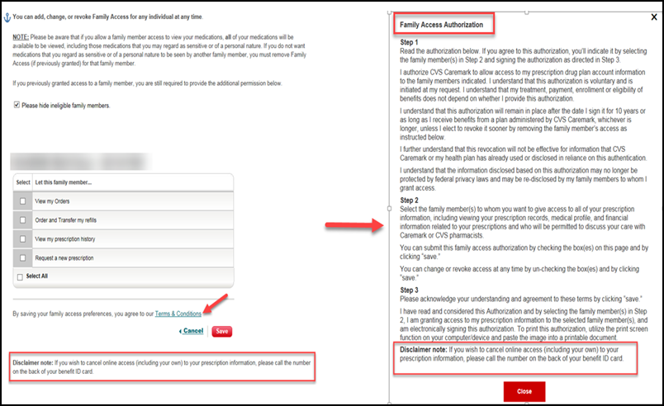

Top of the Document

|  |
| --- |
| Family Access Screen |

Have the member follow these steps to grant **Family Access**:

|  |  |
| --- | --- |
| **Step** | **Action** |
| **1** | **Customer Care Representative:** Authenticate the caller. |
| **2** | **Member:** Access [www.caremark.com](http://www.caremark.com) and sign in. |
| **3** | Click **Account** then select **Family Access**. |
| **4** | Click **Family Access** located in the left menu.  **Note:** The **Family Access** link will not display for members who do not have dependents covered on their plan.    Members can grant **Family Access** to dependents age 18 and older to allow registered adult family members view their prescription information from their profile on Caremark.com. The minimum age can vary based on the client. If there are no members of the family over the age of 18, the page will state “There are no other users registered with the same participant code.” |
| **5** | The member can select the specific categories in which they want to grant family access for and click the “**Save**” button.  Categories include:   * **View my Orders** * **Order and Transfer my refills** * **View my prescription history** * **Request a new prescription**   Members covered under FEP (Client Z6500) have the following additional categories:   * **View my prior approval status** * **Request my coverage exception**   The member can also check the **Select All** box and click the **“Save”** button if desired.  **Note:** FEP members have the additional options indicated.    **Note:** When granting Family Access to other adult family members, it can take up to 24 hours for the Family Access settings to be refreshed and take effect. If it has been less than 24 hours since the family access has been granted, advise the caller to check again after 24 hours. If the member continues to have an issue with viewing prescription information for their family member after 24 hours have passed, please submit a web error form to report the issue for further research.   * Members must select the checkboxes **OR** click **Select All.** * Then,click **Save** for the Family Access settings to take effect.     Here’s what to do if the caller asks, “Is it possible to see my spouse’s information on my account?”   * Explain that the member’s spouse must log into their own account and grant **Family Access** to the caller. If the member that is calling wants to grant **Family Access** to their spouse, they can check the boxes next to their spouse’s name and click Save.   + - If the spouse is not available to give verbal permission, view the spouse’s account to determine if the spouse has granted **Family Access** to the caller.     - If so, then you can explain how the caller can log into their own account to access the spouse’s information.     - We can always assist the caller with their own specific web account. |

Top of the Document

|  |
| --- |
| Remove Family Access |

Perform the steps below:

|  |  |
| --- | --- |
| **Step** | **Action** |
| **1** | Authenticate the caller. |
| **2** | Follow steps 2 through 4 above to help the member locate the **Family Access** page. |
| **3** | The member can remove family access by un-checking the boxes and clicking the **Save** button.  **Note:** If a member’s registration has been deleted, the family access previously granted to their family member(s) when they were registered cannot be updated or removed. The member will need to re-register to make changes to family access. If the member receives an error when re-registering, submit a Web Error Form to request the family access be removed for the member.  Customer Care representatives are **not** allowed to alter, change, register, or delete Protected Health Information. Customer Care representatives **cannot** check or uncheck the **Family Access** boxes for a member. The member must make these selections.   * Always authenticate before releasing PHI to callers or providing someone access to the website. The caller will have access to medical information, billing information, and prescription information on the website. * Everyone 18 years of age or older has the right to privacy. Some plans may have a lower registration age. Refer to the client CIF. * Information on the Caremark.com website is considered Protected Health Information; as a result, information disclosed or released about account information is protected. |

Top of the Document

|  |
| --- |
| Questions/Answers |

Use the following scenarios to determine appropriate action:

|  |  |
| --- | --- |
| **Question** | **Answer** |
| **I am a dependent of my parents living at home and want to use Caremark.com. Can my mom register for me?** | Everyone who uses Caremark.com, age 18 years of age and over, must register with a separate username and password. Registration age can be client specific. Refer to the client CIF. |
| **Can I use the same password as my spouse who is my dependent?** | The same username/password cannot be shared by a spouse or any dependent under the same plan. |
| **Can I view my spouse’s prescription history? Can my spouse view my information?** | Once registered, you can grant Family Access to your spouse/dependent to allow them to view your prescription information. |

Top of the Document

|  |
| --- |
| Related Documents |

**Parent SOP:** [CALL 0045 Customer Care Web Support Email Response and Handling](https://policy.corp.cvscaremark.com/pnp/faces/DocRenderer?documentId=CALL-0045)

[CALL 0011 Authenticating Caller](https://policy.corp.cvscaremark.com/pnp/faces/DocRenderer?documentId=CALL-0011)

**Abbreviations/Definitions:** Customer Care Abbreviations, Definitions, and Terms Index (017428)

**Index:** Caremark.com - Work Instruction/Job Aid Index (105672)

Top of the Document

Not To Be Reproduced Or Disclosed to Others Without Prior Written Approval

**ELECTRONIC DATA = OFFICIAL VERSION / PAPER COPY = INFORMATIONAL ONLY**